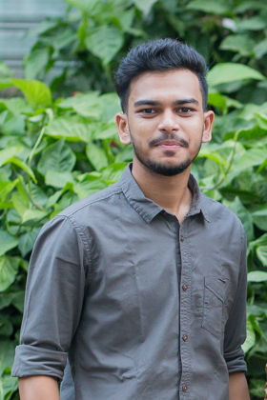

Student & Programmer

# Education

**Bachelor in Computer Science and**

**Engineering (B. Sc in C.S.E) 2021-present**

Daffodil International University

**Higher Secondary Certificate 2019**

Noakhali Govt. College

4.75

**Secondary School Certificate 2017**

Noakhali Zilla School

4.73

# Technical Skill

* Programming Languages: C, C++, Python, HTML, CSS, JavaScript
* Version Control: Git, GitHub
* Office Tools: Microsoft Office 2016(Word, PowerPoint), Google Docs
* Operating System: Windows

# Experience

**Dissertation**, Name of Institution, Location 20__

Advisor: Name

* Skill/Accomplishment/Project

# Achievement And Awards

* DIU take-off Programming Contest 2021
* DIU Intra University Programming Contest 2021
* Solved more than 500 problem in various online Judge

# **Reference**

**Dr. -- ------**, [Title]

[Department Name]

[University Name]

[Mailing Address]

Phone: [Phone #]

Email: [email address]

**Phone:**

01750036049

**E-Mail:**

[washikfaieaz@gmail.com](mailto:washikfaieaz@gmail.com)

**GitHub:**

[**https://github.com/washik6049**](https://github.com/washik6049)

**Adress:**

Nur nobi chairmanbari,Maijdee court,Noakhali

# Personal Details

**Date of Birth:**

29/11/2000

**Nationality:**

Bangladeshi

**Marital Status:**

Single

# Languages

Bengali

English

# **Publications**

**Books**

Last name, F.M., Book Title, Location: Publisher, 2021

# Projects

* **Calculator**

Scientific Calculator software with C

WASHIK WALI FAIEAZ